**First-Time HAX User Tutorial Content**

**TEXT to be copied**

*Copy and paste these paragraphs of textual narrative into HAX as directed in the video.*

--------------------------------------------------------------------------------

In Australian Aboriginal culture, a songline -- also called a 'dreaming track' -- is a path from the creator-beings across the land, described in songs, paintings, and dance. Consider this for a moment: a physical topography is made - or re-made - with an ephemeral action.

The author Bruce Chatwin puts it this way:  “The melodic contour of the song describes the land over which the song passes ... certain phrases, certain combinations of musical notes, are thought to describe the actions of the ancestors’ feet. An expert song man … would count how many times he has crossed a river or scaled a ridge – and be able to calculate where, and how far along, the songline he was ... A musical phrase is a map reference. Music is a memory bank for finding one’s way about the world.”

In fact, the songlines arguably bring the world into existence with each performance. What an apt metaphor for thinking about a designerly engagement with the world! We literally bring the world into existence when we design.

And it leaves us with many things to think about... What's the distinction between art, science, and design? Why do we design? Is it out of need, necessity, or a desire to change the world in some way?

These are some of the questions we'll tackle in this lecture. We'll also see how design can be seen as a technology itself. Here the idea of technology is a bigger one – the ways and means of working – and it is illustrated by stories about a church steeple and the design of railway cars.

This TED talk by the designer of the iPod and the Nest thermostat discusses how design can address problems that are so familiar that we don’t even see them anymore.  Watch it here.

This video features internationally known landscape architect Darrel Morrison reflecting on the origins of his approach to design and on his mentors and inspirations. (13:00 video)

--------------------------------------------------------------------------------

**IMAGES to be saved as files**

*Save these images to your computer as directed in the tutorial video.*

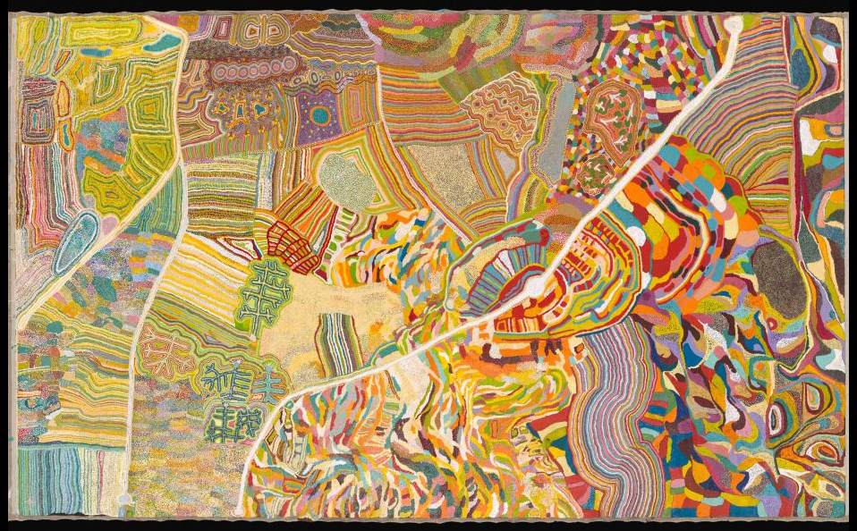

*CAPTION:* An example of a song line in painting, an aerial view of a landscape.

*CITATION:* Girgirba, Kumpaya, et al. Yarrkalpa (Hunting Ground). 2013, acrylic on linen, National Museum of Australia. <https://www.nma.gov.au/exhibitions/songlines> Accessed 18 Aug. 2023.

*ALT TEXT:* A painting of many colors, lines, and shapes that represent an aerial view of a landscape.

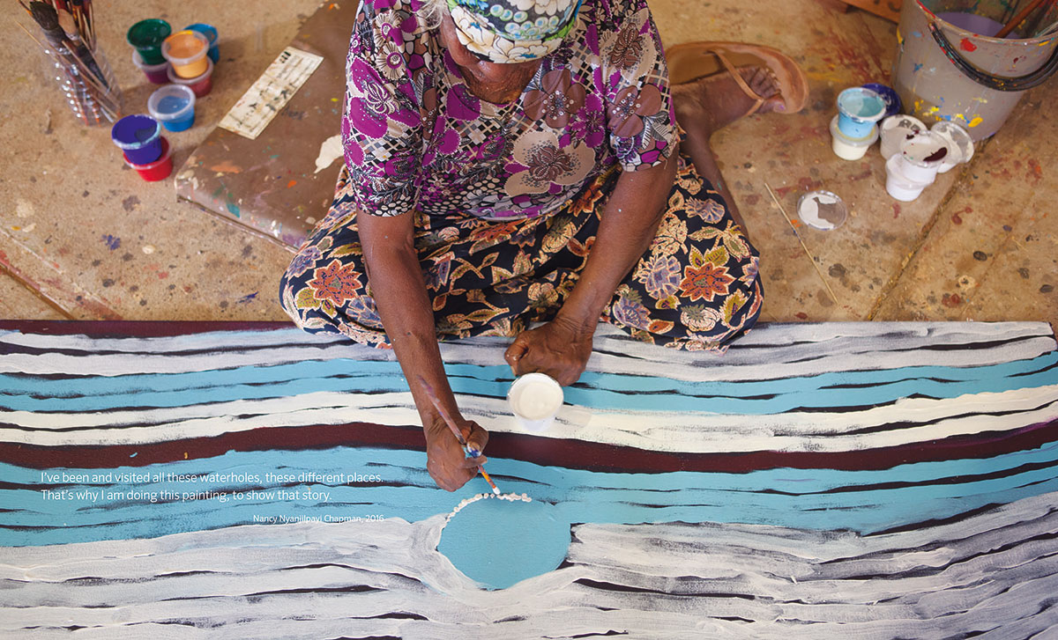

*CAPTION:* A woman painting the visual story of various waterholes she has visited.  
  
*CITATION:* "Songlines: Tracking the Seven Sisters." National Museum of Australia, National Museum of Australia, 2017, [www.nma.gov.au/about/publications/songlines](http://www.nma.gov.au/about/publications/songlines). Accessed 18 Aug. 2023.

*ALT TEXT:* A woman painting the visual story of various waterholes she has visited.

--------------------------------------------------------------------------------

**LECTURE VIDEO LINK to be copied**

*Copy and paste this lecture video link into HAX as directed in the tutorial video.*

(Design as a Mindset and Approach to Engaging the World)

https://www.youtube.com/watch?v=nTWcKvi1mlc&t=5s

--------------------------------------------------------------------------------

**EXTERNAL VIDEO LINKS to be copied**

*Copy and paste these video links into HAX as directed in the tutorial video.*

(The First Secret is Noticing)

http://www.ted.com/talks/tony_fadell_the_first_secret_of_design_is_noticing?language=en

--------------------------------------------------------------------------------

(Designing in the Prairie Spirit)

http://lalh.org/films/designing-in-the-prairie-spirit/

--------------------------------------------------------------------------------